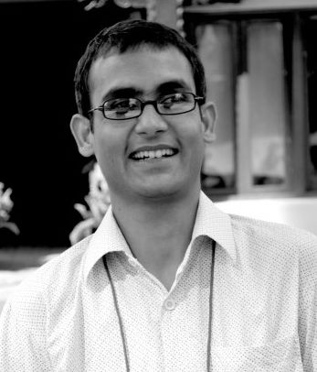

I am Suman Mandal. I am a teacher by profession. I have been active in SEBS since 2008. I served as Executive Member, Treasurer and am the 2nd Vice President in the outgoing Ex-Com.

In the 33rd AGM, I am running for the 1st Vice President. My involvement in the SEBS for the past 7 years shows that I am committed to serving my Alma Mater and most importantly I can avail myself as required by the SEBS.

After the April 25 Earthquake in Nepal, I was actively involved in the Relief Action Project that SEBS initiated. Now that we have entered into the reconstruction phase, I would like to contribute in rebuilding school – a project that SEBS has initiated under the leadership of SEBS’s first President Komal Karki dai.

Therefore, I think I am a suitable candidate for the post of the 1st Vice President. I sincerely ask you to vote for me.

Thank you!

Suman Mandal